Serverless Architecture with Terraform and Google Cloud Platform (GCP) Services

Date: 3/2021

#### 

#### 

Authors: Ken Yee, Venkat Pallem, Chida Chidambaram

Prepared for: KX Assets

Contents

1. Cloud Automation 3

1.1 Tools 3

1.1.1 Terraform 3

1.1.2 Benefits of Terraform 4

1.1.2.1 Self-service 4

1.1.2.2 Speed and safety 4

1.1.2.3 Reusability 4

1.1.2.4 Validation 4

1.1.3 Challenges with Terraform 5

2. Serverless Architecture using GCP Services with Terraform 5

2.1 Serverless Computing 5

2.1.1 Google Cloud Source Repositories (GCSR) 5

2.1.2 Google Cloud Storage (GCS) 5

2.1.3 Google Cloud Build (GCB) 6

2.1.4 Google Container Registry (GCR) 6

2.2 GCP Infrastructure Deployment – Serverless Architecture 6

2.2.1 Build Frontend UI or Intake Form 7

2.2.2. Setup Cloud Source Repository 8

2.2.2.1 Create a repository 8

2.2.2.2 Clone a repository 8

2.2.2.3 Create a "Hello, World!" script 8

2.2.2.4 Create an app.yaml file 9

2.2.2.5 Push to Cloud Source Repositories 9

2.2.2.6 View files in the repository 10

2.2.3 Integrate Cloud Build with Cloud Source Repositories 10

2.2.4 Build Terraform Container 12

2.2.5 Configure Terraform to store state in a Cloud Storage bucket 12

2.2.6 Configure Terraform in build.yaml to trigger scripts 13

2.2.7 Promote changes to the Dev/Prod environment branches 15

3. Benefits of Serverless Architecture 15

4. Conclusion 16

Appendix A 17

UI Integration Deployment Patterns & Recommendation 17

Terraform Deployment using Jenkins (parameters feature) 17

Terraform Deployment using Jenkins & SNOW 17

# 

# 

# 1. Cloud Automation

Automation is an end-to-end work process enabled by collaborating multiple tools and technologies to produce and deliver products and services with minimal human intervention. The implementation of automation technologies, techniques and processes improve the efficiency, reliability and speed of many tasks that were previously performed by humans. In the IT domain, a software script can test a software product and produce a report within a quick time frame. It makes sure the techniques are used effectively in the delivery of products and services.

Managing and provisioning infrastructure in the cloud usually involves a Web interface or issuing commands in the terminal. These options work well for individuals and small teams but prove troublesome for larger teams with complex requirements. As more organizations migrate to the cloud, CIOs want hybrid and multi-cloud solutions. Infrastructure as code is one way to manage this complexity.

## 1.1 Tools

In this section, we provide an overview, highlight the benefits, and challenges of Terraform. It is one of the most popular and commonly used infrastructure as code tool for cloud automation. The below section explains why Terraform would be a better choice over cloud native Google Cloud Deployment Manager or AWS Cloud Formation.

### 1.1.1 Terraform

Terraform is an open source “Infrastructure as a Code” tool. It is used as a tool for building, changing, and versioning infrastructure safely and efficiently. It can help with multi-cloud by having one workflow for all clouds. The Terraform managed infrastructure can be hosted on public clouds like Amazon Web Services, Microsoft Azure, and Google Cloud Platform, or on-prem in any private clouds. It can provision infrastructure across multiple cloud and on-premises [data centers](https://www.ibm.com/cloud/learn/data-centers) and can re-provision infrastructure safely and efficiently in response to configuration changes.

### 1.1.2 Benefits of Terraform

Here are the benefits and values of leveraging Terraform.

#### 1.1.2.1 Self-service

Most teams that deploy code manually have a small number of sysadmins (often, just one) who are the only ones who know all the magic incantations to make the deployment work and are the only ones with access to production. This becomes a major bottleneck as the company grows. If your infrastructure is defined in code, then the entire deployment process can be automated, and developers can kick off their own deployments whenever necessary.

#### 1.1.2.2 Speed and safety

An automated deployment process is significantly faster because a computer can carry out the deployment steps far faster than a person can. It is also safer since an automated process will be more consistent, more repeatable, and not prone to manual error.

#### 1.1.2.3 Reusability

You can package your infrastructure into reusable modules, so that instead of doing every deployment for every product in every environment from scratch, you can build on top of known, documented, battle-tested pieces. Terraform is a great fit for your multi-cloud requirements. Code reuse and standardization across providers are both important factors.

#### 1.1.2.4 Validation

If the state of your infrastructure is defined in code, then for every single change, you can perform a code review, run a suite of automated tests, and pass the code through static analysis tools, all practices that are known to significantly reduce the chance of defects.

### 1.1.3 Challenges with Terraform

Terraform requires a runtime environment to be triggered and executed. Typically, this is accomplished by installing Terraform in a virtual machine hosted in a cloud. This virtual machine becomes a critical path for infrastructure provisioning and needs to be backup for reliability and patched for security requirements.

Secondly, Terraform faces the challenge of integrated User Interface (UI) to enhance user experience of providing variables or parameters to deploy any resources. Currently, this is mostly done via Terraform Command Line Interface (CLI).

# 2. Serverless Architecture using GCP Services with Terraform

## 2.1 Serverless Computing

Serverless means no upfront provisioning, no management of servers, and pay-what-you-use economics for building applications. Since the beginning of Client-Server development, IT had to manage servers for application hosting (compute) and application databases. Google Cloud has always believed in the vision of serverless by debuting with Google App Engine in 2008, the first fully serverless compute service. Since then, Google has evolved more serverless offerings in both application development and analytics.

Google Cloud’s serverless platform lets you build, develop, and deploy functions and applications, as source code or containers, while simplifying the developer experience by eliminating all infrastructure management.

The following sections describe the cloud offerings from Google that enable this serverless platform with Terraform.

### 2.1.1 Google Cloud Source Repositories (GCSR)

Google Cloud Source Repositories (GCSR) allows you to design, develop, and securely manage your code. It allows collaboration easily on a fully featured, scalable, and private Git repository. In addition, GCSR extends your Git workflow by connecting to other Google Cloud tools, including Cloud Build, App Engine, Pub/Sub, and operations products such as Cloud Monitoring and Cloud Logging.

### 2.1.2 Google Cloud Storage (GCS)

Google Cloud Storage is a RESTful online file storage web service for storing and accessing data on Google Cloud Platform infrastructure. The service combines the performance and scalability of Google's cloud with advanced security and sharing capabilities. It is an object storage for companies of all sizes which stores any amount of data and retrieves it as often as you would like.

### 2.1.3 Google Cloud Build (GCB)

Cloud Build is a service that executes your builds on Google Cloud Platform's infrastructure. Cloud Build can import source code from a variety of repositories or cloud storage spaces, execute a build to your specifications, and produce artifacts such as Docker containers or Java archives.

### 2.1.4 Google Container Registry (GCR)

Container Registry is a single place for your team to manage Docker images, perform vulnerability analysis, and decide who can access what with fine-grained access control. Existing CI/CD integrations let you set up fully automated Docker pipelines to get fast feedback.

## 2.2 GCP Infrastructure Deployment – Serverless Architecture



*Figure 1a: Build and Deploy process of GCP Serverless Architecture with Terraform*



*Figure 1b: Build and Deploy process of GCP Serverless Architecture with Terraform*

In this architecture, all the above mentioned GCP offerings in section 2.1 are utilized with Terraform to create a truly serverless environment for deploying infrastructure cloud resources. These are the processed or steps to set this up. They are:

1. Build frontend UI or Intake form
2. Set up Cloud Source Repository
3. Integrate Cloud build with Cloud Source Repository
4. Build Terraform Container
5. Configure Terraform to store state in a Cloud Storage bucket
6. Configure Terraform in build.yaml to trigger scripts
7. Promote changes to the development/Production environment

### 2.2.1 Build Frontend UI or Intake Form

We have built an intake form with a combination of python and JavaScript to provide customer a unified input mechanism for values to any GCP resources, for example, project, virtual private network, subnet, compute, storage, etc. These values are then stored in a Cloud Source Repository which in turn will trigger the Terraform pipeline. These are the events that will take place upon submission of this intake form.

1. Populate intake form
2. Read the variables from intake form
3. Build the tfvars file based on the data received from intake and inputs required for Terraform code
4. Add and Push the changes to Cloud Source Repository

### 2.2.2. Setup Cloud Source Repository

Please follow the guidelines below to setup and use Google Cloud Source Repository.

Before you begin, please make sure the steps are completed:

* In the Google Cloud Console, on the project selector page, select or create a Google Cloud project
* Make sure that billing is enabled for your Cloud project. Learn how to confirm that billing is enabled for your project
* Install and initialize the Cloud SDK
* Verify that you have the latest version of Git
* Enable the Cloud Source Repositories API

#### 2.2.2.1 Create a repository

In a terminal window, use the gcloud source repos create command to create a Google Cloud repository named hello-world:

*gcloud source repos create hello-world*

#### 2.2.2.2 Clone a repository

Use the gcloud source repos clone command to clone the contents of the Google Cloud repository into a local Git repository:

*gcloud source repos clone hello-world*

#### 2.2.2.3 Create a "Hello, World!" script

Create a Python script that prints Hello, World! in a browser window.

* Go to your hello-world repository.
* Using a text editor, create a file named main.py, and then paste the following code:

*#!/usr/bin/env python*

*import webapp2*

*class MainHandler(webapp2.RequestHandler):*

*def get(self):*

*self.response.write('Hello, World!')*

*app = webapp2.WSGIApplication([*

*('/', MainHandler)*

*], debug=True)*

#### 2.2.2.4 Create an app.yaml file

Create an app.yaml file that contains the configuration information you need to deploy your code to App Engine.

* Go to your hello-world repository.
* Using a text editor, create a file named app.yaml, and then paste the following configuration information:

*runtime: python27*

*api_version: 1*

*threadsafe: yes*

*handlers:*

*- url: .\**

*script: main.app*

*libraries:*

*- name: webapp2*

*version: "2.5.2"*

#### 2.2.2.5 Push to Cloud Source Repositories

Push the files you just created into Cloud Source Repositories.

* In a terminal window, go to your hello-world directory:

*cd hello-world*

* Add the files:

*git add .*

* Commit the files to the repository with a comment describing the history of this action:

*git commit -m "Add Hello World app to Cloud Source Repositories"*

* Using the git push command, add the contents of the local Git repository to Cloud Source Repositories:

*git push origin master*

* Git pushes the files from the master branch to the origin remote. Output similar to the following is displayed:

*Counting objects: 21, done.*

*Delta compression using up to 6 threads.*

*Compressing objects: 100% (20/20), done.*

*Writing objects: 100% (21/21), 9.76 KiB | 0 bytes/s, done.*

*Total 21 (delta 5), reused 0 (delta 0)*

*remote: Storing objects: 100% (21/21), done.*

*remote: Processing commits: 100% (6/6), done.*

*To https://source.developers.google.com/p/example-project-1244/r/repo-name*

*\* [new branch] master -> master*

#### 2.2.2.6 View files in the repository

* In the Google Cloud Console, open Cloud Source Repositories.
* Click the name of the hello-world repository that you created.
* Go to the files you pushed to the repository.
* The GCP Console shows the files in the master branch at the most recent commit.
* In the Files list, click a file to view its contents.

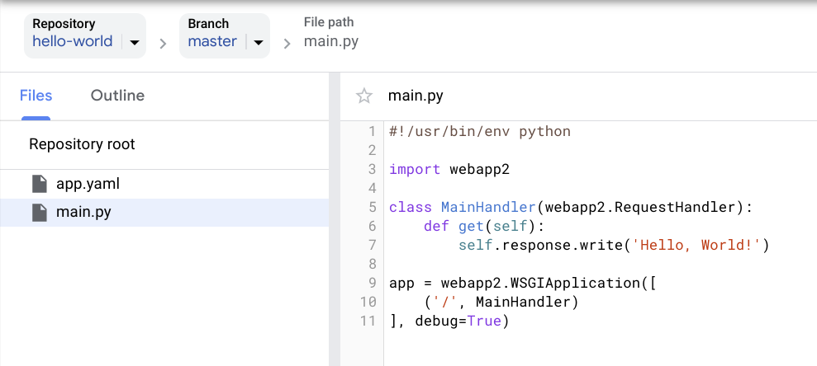

* You can also view the files by using Cloud Shell.

### 2.2.3 Integrate Cloud Build with Cloud Source Repositories

This section describes how to automate builds using Cloud Build and Cloud Source Repositories.

You can configure Cloud Build to automatically build a new image any time a user pushes a change to files stored in Cloud Source Repositories. Events that initiate automatic builds are called *build triggers*. These triggers can help ensure that your container images are kept up to date. You can also use them to build and test feature branches.

Before you begin, please make sure the following steps are completed:

* Enable the Cloud Build API.
* Ensure you have source code in Cloud Source Repositories.
* Ensure you have either a [Dockerfile](https://cloud.google.com/source-repositories/docs/integrating-with-cloud-build#using_a_dockerfile) or a [Cloud Build build config file](https://cloud.google.com/source-repositories/docs/integrating-with-cloud-build#using_a_build_config_file).

In addition to the prerequisites, you might find the following information helpful:

* Build triggers use shallow clones of a repository. With shallow clones, only the single commit that triggered an automatic build is checked out in the workspace. For more information, and to learn how to include more of your repositories history, see [Unshallowing clones](https://cloud.google.com/source-repositories/docs/integrating-with-cloud-build#unshallowing_clones).
* If you use another hosted Git provider, such as on GitHub or Bitbucket, and still need to mirror the repository into Cloud Source Repositories, you must have the cloudbuilds.builds.create permission for the Google Cloud project with which you're working. This permission is typically granted through the [cloudbuild.builds.editor](https://cloud.google.com/build/docs/securing-builds/configure-access-control#roles) role.
* When you set up a build trigger with an external repository for the first time, you'll need to set up authorization with that repository. For more information, see [Adding a repository as a remote](https://cloud.google.com/source-repositories/docs/adding-repositories-as-remotes).
* After you set up your external repository, Cloud Source Repositories creates a mirror of your repository.
* For information on the quotas and limits for Cloud Build, see [Quotas and limits](https://cloud.google.com/build/quotas) in the Cloud Build documentation.

To create a new build trigger, follow these steps:

1. In the Google Cloud Console, open the Cloud Build ***Build triggers*** page.
2. [Open the Build triggers page](https://console.cloud.google.com/cloud-build/triggers)
3. Select your Google Cloud project and click Open.
4. The Triggers page opens.
5. Click Create Trigger.
6. The Create trigger page opens.
7. In the Repository drop-down list, select a repository from the list of available repositories.
8. Fill out the following options:
   * Optional. In the ***Description*** field, enter a name for your trigger.
   * Optional. In the ***Trigger type*** list, you can set a trigger to start a build on commits that are made to a particular *branch*, or on commits that contain a particular *tag*. In either case, you can specify a regular expression with the branch or tag value to match.
   * In the ***Build configuration*** list, select a config file type to use for each build that the trigger starts. You can select and specify a Dockerfile, or you can select a Cloud Source Repositories configuration file (located in the remote repository). If necessary, review the information on this page about building with a [Dockerfile](https://cloud.google.com/source-repositories/docs/integrating-with-cloud-build#using_a_dockerfile) or a [build config file](https://cloud.google.com/source-repositories/docs/integrating-with-cloud-build#using_a_build_config_file).
9. Click ***Create trigger.***

### 2.2.4 Build Terraform Container

Perform the below one-time activity to build the container image as required for the use case and push to container registry.

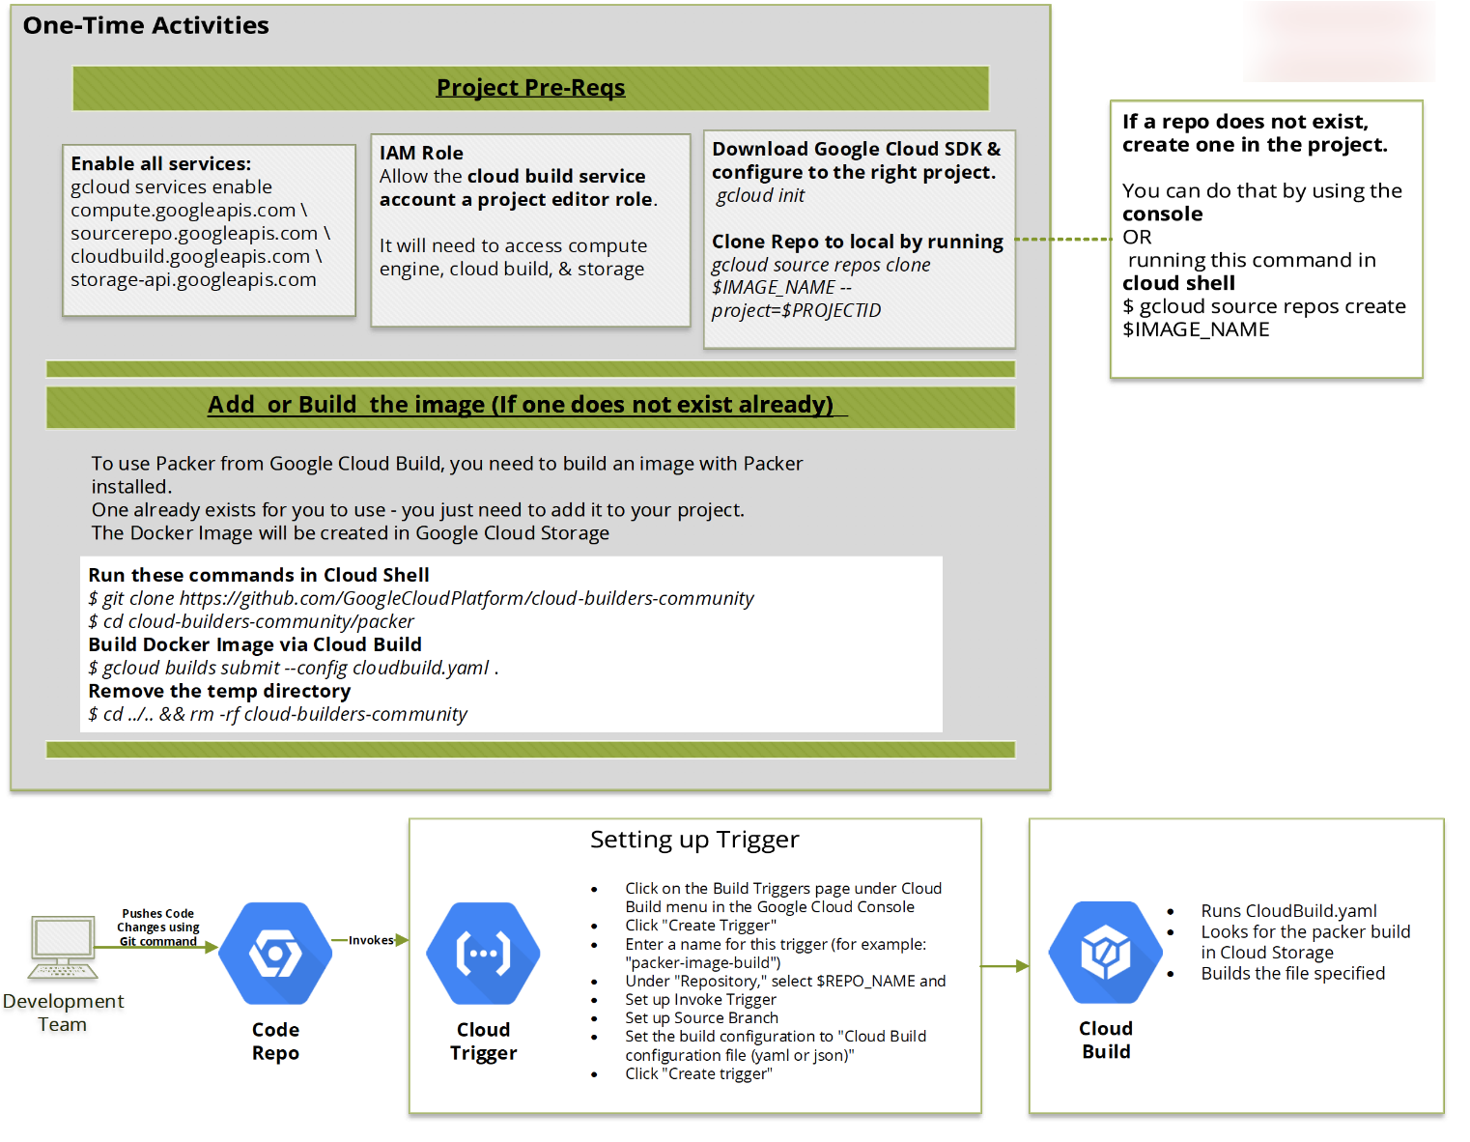

*Figure 2: Cloud Build integration with Cloud Source Repository and Cloud Build*

### 2.2.5 Configure Terraform to store state in a Cloud Storage bucket

As a best practice, instead of storing bucket into a local storage options, we recommend pushing the state of bucket to cloud storage GCS so that it helps to track the state and continue to audit and modify the infrastructure. Also need to design the prefixes as per environments accordingly so that it is synchronized with either region or application or module, etc. to help you to track the state files properly.

*terraform{,*

*backend "gcs"{*

*bucket="terraformstate-bucket"*

*#key="d"*

*prefix="tfstate/prod/<replacethisfield>/"*

*}*

*}*

### 2.2.6 Configure Terraform in build.yaml to trigger scripts

We need to build yaml file to tell cloud build how to run the terraform scripts of init, plan, and build from cloud source repository. Please find the steps in detail below:

*- id: 'tf init'*

*name: 'hashicorp/terraform:0.11.14'*

*entrypoint: 'sh'*

*args:*

*- '-c'*

*- |*

*if [ -d "environments/$BRANCH_NAME/" ]; then*

*cd environments/$BRANCH_NAME*

*terraform init*

*else*

*for dir in environments/*/*

*do*

*cd ${dir}*

*env=${dir%*/}*

*env=${env#*/}*

*echo ""*

*echo "*************** TERRAFORM INIT ******************"*

*echo "******* At environment: ${env} ********"*

*echo "*************************************************"*

*terraform init || exit 1*

*cd ../../*

*done*

*fi*

*# [START tf-plan]*

*- id: 'tf plan'*

*name: 'hashicorp/terraform:0.11.14'*

*entrypoint: 'sh'*

*args:*

*- '-c'*

*- |*

*if [ -d "environments/$BRANCH_NAME/" ]; then*

*cd environments/$BRANCH_NAME*

*terraform plan*

*else*

*for dir in environments/*/*

*do*

*cd ${dir}*

*env=${dir%*/}*

*env=${env#*/}*

*echo ""*

*echo "*************** TERRAFOM PLAN ******************"*

*echo "******* At environment: ${env} ********"*

*echo "*************************************************"*

*terraform plan || exit 1*

*cd ../../*

*done*

*fi*

*# [END tf-plan]*

*# [START tf-apply]*

*- id: 'tf apply'*

*name: 'hashicorp/terraform:0.11.14'*

*entrypoint: 'sh'*

*args:*

*- '-c'*

*- |*

*if [ -d "environments/$BRANCH_NAME/" ]; then*

*cd environments/$BRANCH_NAME*

*terraform apply -auto-approve*

*else*

*echo "***************************** SKIPPING APPLYING *******************************"*

*echo "Branch '$BRANCH_NAME' does not represent an oficial environment."*

*echo "*******************************************************************************"*

*fi*

*# [END tf-apply]*

### 2.2.7 Promote changes to the Dev/Prod environment branches

Promoting changes to respective branch based on environments specified. Before pushing to production, make sure you run Terraform Plan on lower-level branches and if that is successfully, then only push the changes to production with Terraform Apply.

With the code in lower-level branches, you can now run Terraform Plan to test the environment of any issues. Accordingly, you can also plan to push the code to production branch with Terraform Apply with Terraform Plan

# 3. Benefits of Serverless Architecture

Tools like Terraform with rapid deployment needs, unpredictable scale requirements and infrastructure maintenance benefits most from serverless computing. Here are the benefits we have uncovered:

1. Harness the capabilities of containers with no infrastructure to manage with Cloud Build. Containers with Terraform software installed can be deployed at runtime to run Terraform scripts and terminated when the scripts are completed. This also save costs in the long run without having the instances/containers running and online at all times.
2. In the same token, there is no webhook or API needed to trigger any Terraform deployment in Cloud Build. This can be accomplished readily through the integration of Cloud Source Repository with Cloud Build.
3. Portability of containers. Terraform containers can store and/or move readily to other cloud platforms or on-premise environment due to this inherent capability of Docker containers. There is no additional configuration or installation needed to move to these platforms/environments which results in IT efficiency and agility.
4. Newer versions of Terraform running in Docker containers can be built anytime and store in Cloud Container Registry leveraging the cloud native capabilities of Google Cloud Platform. These newer versions can be tested through rigorous validation and UAT before rolling out in production.
5. Terraform must store state about your managed infrastructure and configuration. This state is used by Terraform to map real world resources to your configuration, keep track of metadata, and to improve performance for large infrastructures. This state is stored by default in a local file named "terraform. Google Cloud Storage is a prime candidate for storing this state files due to its object store nature and ability to provide >= 99.95% monthly uptime percentage for Standard storage class in a multi-region or dual-region location of Cloud Storage.

# 4. Conclusion

In conclusion, this document provides an overview of Terraform, and stresses the benefits and challenges of using this tool in cloud platform like Google Cloud Platform (GCP). It also describes the values of serverless computing and how it can address the challenges with Terraform.

The benefits of Terraform are self-service for ease of deployment, speed and safety for consistency and repeatable process to minimize manual error, reusability for running the same code in any cloud platform or on-premise environment and lastly, validation with code review, suite of automated tests and others.

Serverless computing lets you build, develop, and deploy functions and applications, as source code or containers, while simplifying the developer experience by eliminating all infrastructure management. Over the years, GCP has introduced new serverless products covering both application development and analytics. We have highlighted some of the key products or offerings in GCP for deploying Terraform in a serverless and containerized architecture.

Most importantly, business benefits like rapid deployment time, lower infrastructure and operations costs can be accomplished by leveraging this kind of architecture and in comparison, to using non-serverless solutions.

# Appendix A

### UI Integration Deployment Patterns & Recommendation

In the following sections, we have recommended few options that we have researched and worked upon.

Based on the infrastructure configuration at client environment, we recommend the below approaches in deploying infrastructure to GCP by choosing the right UI either SNOW or Jenkins Parameters integrated UI) in order to integrate with Terraform/CI-CD tool like Jenkins below example

* Terraform Deployment using Jenkins (parameters feature)
* Terraform Deployment using Jenkins & SNOW

#### Terraform Deployment using Jenkins (parameters feature)

Steps required to use the above approach

1. IT needs to connect to Jenkins console and trigger the pipeline job.
2. IT needs to give the information about the project name, VPC name, region, subnet name and submit it to trigger the pipeline.
3. Once the pipeline starts, it will clean up the Jenkins workspace and fetch the source code from GitHub (pull Terraform code from Cloud Source Repository).
4. After that it will initialize and plan the terraform with the configuration details that has been provided.
5. Jenkins and Terraform are hosted on either a Jenkins VM or a GKE cluster on GCP platform and integration plugins are enabled​.
6. Once terraform initialization done, then it will start the pipeline stages to create and build the GCP resources based on the configuration that has been given via Jenkins UI and terraform files.
7. After all the execution and pipeline completed, it will store the terraform state file in the bucket for future references. ​

#### Terraform Deployment using Jenkins & SNOW

Steps required to use the above approach

1. IT needs to install the ServiceNow and be logged into it for the process.
2. Once logged in, IT can fill out the details in the intake form which will trigger the GitHub source code to store the information.
3. Then GitHub will trigger the Jenkins pipeline to perform the following further process.
4. Once the pipeline starts it will clean up the Jenkins workspace and fetch the source code from GitHub​.
5. After that it will initialize and plan the terraform with the configuration details that has been provided.
6. Jenkins and Terraform hosted on Jenkins VM/GKE cluster on GCP platform and integration plugins are enabled​.

Once terraform initialization is done, it will start the pipeline stages to create and build the GCP resources based on the configuration that has been given via SNOW form and terraform files. After all the execution and pipeline is completed, it will store the terraform state file in the bucket for future references.

**Service now <-> Jenkins integration process**

* Integrate Jenkins orchestration tool with DevOps using the DevOps Integrations application.
* Install the DevOps Integration application and the Jenkins plugin for ServiceNow DevOps to integrate Jenkins with DevOps.

**Jenkins Plugin**

The Jenkins plugin for ServiceNow DevOps is provided to enable change acceleration so that your orchestration tool can communicate with ServiceNow DevOps and control certain aspects of pipeline executions.

**Creating Jenkins tool record in ServiceNow**

Create a Jenkins tool record in DevOps to connect, discover, and import orchestration tasks and pipelines.

1. Create a tool record in DevOps to automatically connect to Jenkins and get the webhook URL.

* Navigate to DevOps > Tools > Create New and create a record.
* Enter a Tool Name and fill in the tool details.
* Click *Submit*.

1. Click *Discover* to discover the existing orchestration tasks (Jenkins stages) and pipelines. Records are added to the corresponding related lists.
2. Open a discovered record from the Orchestration Tasks related list and click the *Import* related link to import historical data from the orchestration task.

**Integrating Jenkins Pipeline with ServiceNow**

For Jenkinsfile pipelines, steps are created, mapped, and associated to orchestration tasks automatically, instead of manually.

1. Map your pipeline to an app in DevOps.

* Navigate to DevOps > Apps & Pipelines > Apps and open the application record to associate with the pipeline.
* In the Pipelines related list, click *Edit*.
* To select a pipeline to associate with the app, or click *New* to create the pipeline.
* For a new pipeline, fill in the Orchestration pipeline field using the full project name as specified in Jenkins.
* Click *Submit*.

1. Open the pipeline record again and select the *Track* checkbox so events from the pipeline are received.
2. Create DevOps steps to map to each Jenkins pipeline stage so an orchestration task can be created.

Steps can be created in one of the following ways.

* For declarative or scripted pipelines, run your Jenkins pipeline to automatically create and map pipeline steps in DevOps.
* Pipeline steps are automatically created, mapped, and associated when DevOps receives step notifications from your Jenkins pipeline during the run.
* For freestyle jobs, manually create and map each pipeline step to a Jenkins pipeline job.
* In the Steps related list, click *New* to create a DevOps step for each Jenkins pipeline stage

1. In Jenkins, navigate to Manage Jenkins > Configure System, select the *ServiceNow DevOps Enabled* check box in the ServiceNow DevOps Configuration section, and fill in the fields.
2. When enabled, Jenkins starts sending events to DevOps as inbound events